**WEEK 7:**

**Q. Create a React Application named “cricketapp”:**

1.In src/components/ListOfPlayers.js

import React from 'react';

const playersData = [

{ name: 'Player1', score: 88 },

{ name: 'Player2', score: 54 },

{ name: 'Player3', score: 73 },

{ name: 'Player4', score: 69 },

{ name: 'Player5', score: 91 },

{ name: 'Player6', score: 47 },

{ name: 'Player7', score: 77 },

{ name: 'Player8', score: 82 },

{ name: 'Player9', score: 65 },

{ name: 'Player10', score: 99 },

{ name: 'Player11', score: 58 },

];

export function ListOfPlayers() {

const allPlayers = playersData.map((p, idx) => (

<li key={idx}>

{p.name}: {p.score}

</li>

));

const belowSeventy = playersData

.filter(p => p.score < 70)

.map((p, idx) => (

<li key={`low-${idx}`}>

{p.name}: {p.score}

</li>

));

return (

<div>

<h2>All Players</h2>

<ul>{allPlayers}</ul>

<h3>Players with score below 70</h3>

<ul>{belowSeventy}</ul>

</div>

);

}

2. In src/components/IndianPlayers.jsx

import React from 'react';

export function IndianPlayers() {

const team = ['Rohit', 'Virat', 'Jadeja', 'Bumrah', 'Shami', 'Kohli', 'Shreyas', 'Iyer', 'Pant', 'Ashwin', 'Siraj'];

const oddTeam = team.filter((_, idx) => (idx + 1) % 2 === 1); // positions 1,3,5...

const evenTeam = team.filter((_, idx) => (idx + 1) % 2 === 0); // 2,4,6...

const T20players = ['Hardik', 'Surya', 'Ishan'];

const RanjiTrophy = ['PlayerA', 'PlayerB', 'PlayerC'];

// Merge using spread

const mergedPlayers = [...T20players, ...RanjiTrophy];

return (

<div>

<h2>Odd Team Players</h2>

<ul>{oddTeam.map((p, i) => <li key={`odd-${i}`}>{p}</li>)}</ul>

<h2>Even Team Players</h2>

<ul>{evenTeam.map((p, i) => <li key={`even-${i}`}>{p}</li>)}</ul>

<h2>Merged Players (T20 + Ranji)</h2>

<ul>{mergedPlayers.map((p, i) => <li key={`merged-${i}`}>{p}</li>)}</ul>

</div>

);

}

3. In src/App.jsx

import React from 'react';

import { ListOfPlayers } from './components/ListOfPlayers';

import { IndianPlayers } from './components/IndianPlayers';

function App() {

const flag = true; // toggle to false to see the other view

return (

<div style={{ padding: '1rem', fontFamily: 'sans-serif' }}>

<h1>Cricket App</h1>

{flag ? (

<div>

<ListOfPlayers />

<IndianPlayers />

</div>

) : (

<div>

<p>Flag is false: showing alternate content</p>

<ListOfPlayers />

</div>

)}

</div>

);

}

export default App;

4. In src/index.js

import React from 'react';

import { createRoot } from 'react-dom/client';

import App from './App';

import './index.css'; // optional, create this if you want basic styling

const container = document.getElementById('root');

const root = createRoot(container);

root.render(

<React.StrictMode>

<App />

</React.StrictMode>

);

* **OUTPUT:**

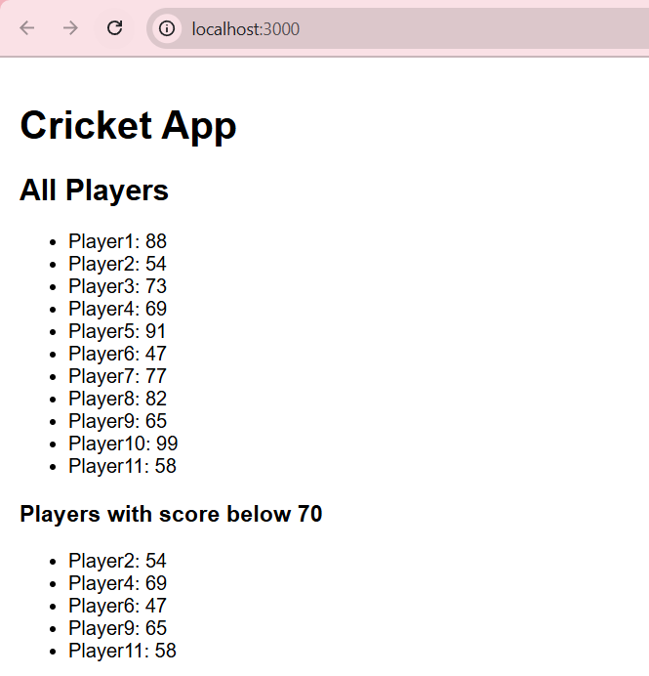

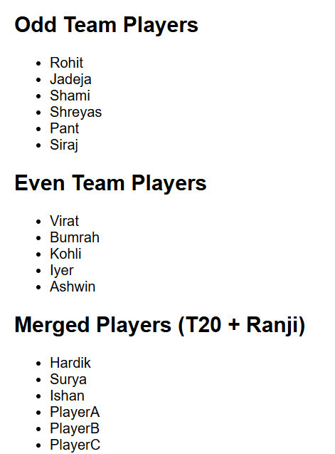

**Q. Create a React Application named “officespacerentalapp” which uses React JSX to create elements, attributes and renders DOM to display the page.**

1. In src/App.js

import React from "react";

function App() {

const officeList = [

{ name: "Workspace A", rent: 55000, address: "MG Road, Bengaluru" },

{ name: "Workspace B", rent: 65000, address: "Powai, Mumbai" },

{ name: "Workspace C", rent: 45000, address: "Connaught Place, Delhi" },

{ name: "Workspace D", rent: 75000, address: "Salt Lake, Kolkata" },

];

return (

<div style={{ fontFamily: "Arial, sans-serif", padding: "1rem" }}>

<h1>Office Space Rental</h1>

<img

src="https://via.placeholder.com/600x200?text=Office+Space"

alt="Office space"

style={{ width: "100%", borderRadius: "8px", marginBottom: "1rem" }}

/>

<ul style={{ listStyle: "none", padding: 0 }}>

{officeList.map((office, idx) => (

<li

key={idx}

style={{

marginBottom: "1rem",

padding: "1rem",

border: "1px solid #ddd",

borderRadius: "8px",

background: "#fafafa",

}}

>

<h2>{office.name}</h2>

<p

style={{

color: office.rent < 60000 ? "red" : "green",

fontWeight: "bold",

}}

>

Rent: ₹{office.rent.toLocaleString()}

</p>

<p>Address: {office.address}</p>

</li>

))}

</ul>

</div>

);

}

export default App;

2. In src/index.js

import React from "react";

import { createRoot } from "react-dom/client";

import App from "./App";

const root = createRoot(document.getElementById("root"));

root.render(

<React.StrictMode>

<App />

</React.StrictMode>

);

* **OUTPUT:**

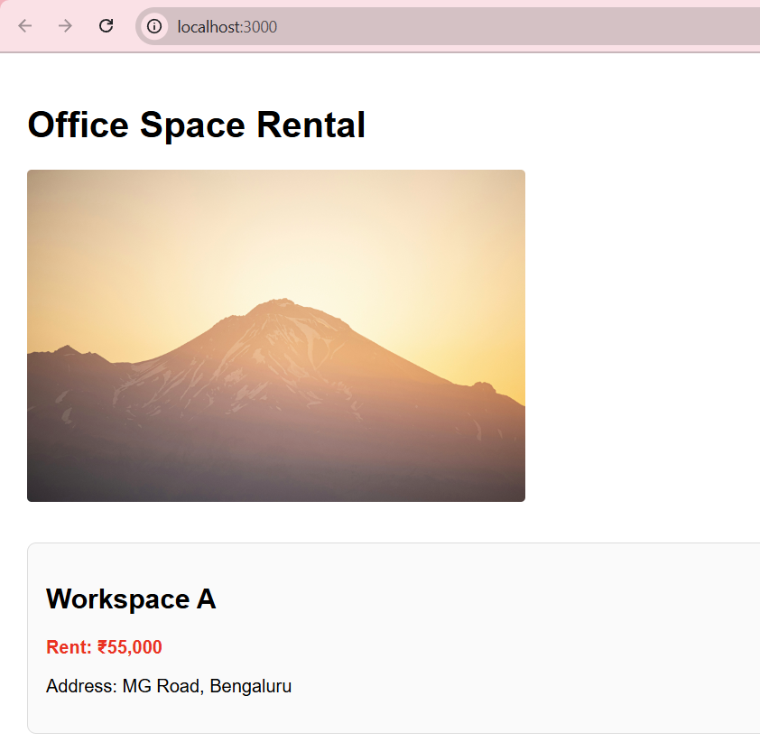

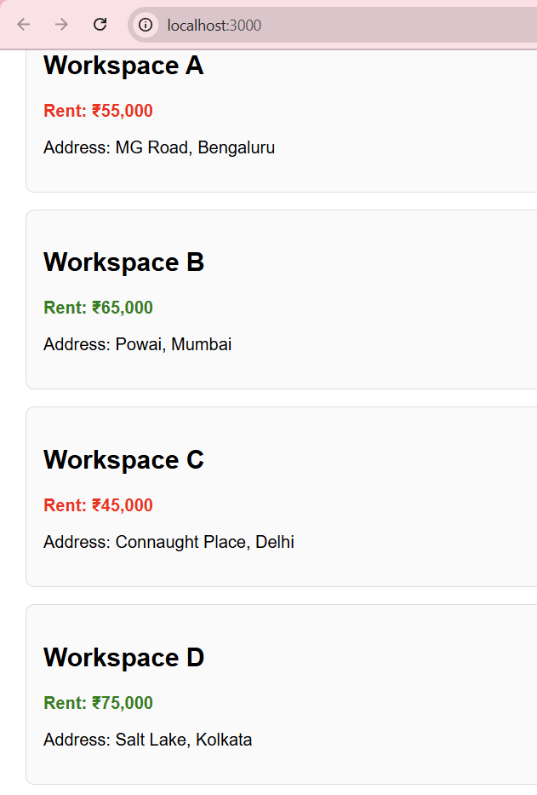

**Q. Create a React Application “eventexamplesapp” to handle various events of the form elements in HTML.**

1. In src/App.js

import React, { useState } from "react";

function CurrencyConverter({ onResult }) {

const [amount, setAmount] = useState("");

const [currency, setCurrency] = useState("");

const handleSubmit = (e) => {

e.preventDefault();

// Simple conversion: assume input is INR and target is EUR

const rateINRtoEUR = 0.011; // 1 INR = 0.011 EUR

if (currency.trim().toUpperCase() === "EUR") {

const euros = (parseFloat(amount) * rateINRtoEUR).toFixed(2);

onResult(`${amount} INR = ${euros} EUR`);

} else {

onResult(`Unsupported currency "${currency}". Use "EUR".`);

}

};

return (

<div style={{ marginTop: "1rem" }}>

<h1 style={{ color: "green" }}>Currency Convertor!!!</h1>

<form onSubmit={handleSubmit}>

<div style={{ marginBottom: "6px" }}>

<label style={{ display: "inline-block", width: "80px" }}>Amount:</label>

<input

type="number"

value={amount}

onChange={(e) => setAmount(e.target.value)}

style={{ width: "180px" }}

placeholder="INR"

/>

</div>

<div style={{ marginBottom: "6px" }}>

<label style={{ display: "inline-block", width: "80px" }}>Currency:</label>

<input

type="text"

value={currency}

onChange={(e) => setCurrency(e.target.value)}

style={{ width: "180px" }}

placeholder="EUR"

/>

</div>

<button type="submit">Submit</button>

</form>

</div>

);

}

function App() {

const [count, setCount] = useState(5); // initial value 5 to match screenshot

const [message, setMessage] = useState("");

const handleIncrement = () => {

setCount((c) => c + 1);

sayHello();

};

const handleDecrement = () => {

setCount((c) => c - 1);

};

const sayHello = () => {

alert("Hello! Counter updated successfully.");

};

const sayWelcome = (msg) => {

alert(msg);

};

const handleSynthetic = (e) => {

// SyntheticEvent available here

alert("I was clicked");

};

const handleConversionResult = (res) => {

setMessage(res);

};

return (

<div style={{ padding: "1rem", fontFamily: "Arial, sans-serif" }}>

<div style={{ fontSize: "1.5rem", marginBottom: "4px" }}>{count}</div>

<div style={{ display: "flex", flexDirection: "column", gap: "4px", marginBottom: "1rem" }}>

<button onClick={handleIncrement} style={{ width: "100px" }}>

Increment

</button>

<button onClick={handleDecrement} style={{ width: "100px" }}>

Decrement

</button>

<button onClick={() => sayWelcome("welcome")} style={{ width: "100px" }}>

Say welcome

</button>

<button onClick={handleSynthetic} style={{ width: "100px" }}>

Click on me

</button>

</div>

{message && (

<div style={{ marginTop: "0.5rem", fontWeight: "bold" }}>

<p>{message}</p>

</div>

)}

<CurrencyConverter onResult={handleConversionResult} />

</div>

);

}

export default App;

2. In src/components/CurrencyConverter.js

import React, { useState } from "react";

function CurrencyConverter() {

const [rupees, setRupees] = useState("");

const [euros, setEuros] = useState(null);

const handleSubmit = (e) => {

e.preventDefault(); // prevent reload

const rate = 0.011; // Example conversion

setEuros((rupees * rate).toFixed(2));

};

return (

<div>

<h2>Currency Converter</h2>

<form onSubmit={handleSubmit}>

<input

type="number"

placeholder="Enter amount in INR"

value={rupees}

onChange={(e) => setRupees(e.target.value)}

/>

<button type="submit" style={{ marginLeft: "0.5rem" }}>

Convert

</button>

</form>

{euros !== null && <p>{rupees} INR = {euros} EUR</p>}

</div>

);

}

export default CurrencyConverter;

**OUTPUT:**

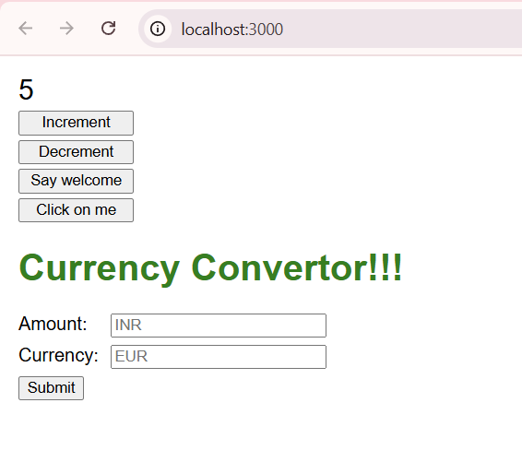

**Q. Create a React Application named “ticketbookingapp” where the guest user can browse the page where the flight details are displayed whereas the logged in user only can book tickets.**

In src/App.js

import React, { useState } from "react";

function GuestView({ onLogin }) {

return (

<div style={{ padding: "2rem", fontFamily: "system-ui, sans-serif" }}>

<h1>Please sign up.</h1>

<button onClick={onLogin}>Login</button>

</div>

);

}

function UserView({ onLogout }) {

return (

<div style={{ padding: "2rem", fontFamily: "system-ui, sans-serif" }}>

<h1>Welcome back!</h1>

<button onClick={onLogout}>Logout</button>

</div>

);

}

function App() {

const [isLoggedIn, setIsLoggedIn] = useState(false);

return isLoggedIn ? (

<UserView onLogout={() => setIsLoggedIn(false)} />

) : (

<GuestView onLogin={() => setIsLoggedIn(true)} />

);

}

export default App;

* **OUTPUT:**

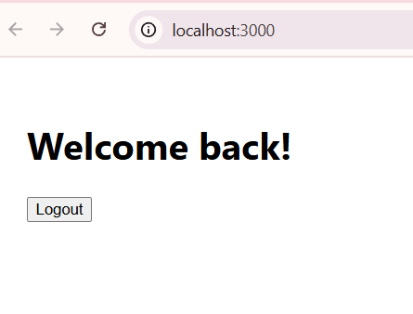

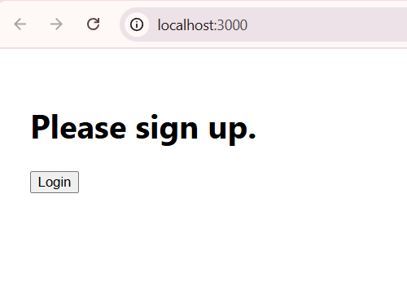

**Q. Create a React App named “bloggerapp”**

1. In src/components/BookDetails.js

import React from "react";

export default function BookDetails() {

const books = [

{ id: 1, title: "Master React", price: 670 },

{ id: 2, title: "Deep Dive into Angular 11", price: 800 },

{ id: 3, title: "Mongo Essentials", price: 450 },

];

return (

<div

style={{

flex: 1,

padding: "0 1rem",

borderLeft: "4px solid green", // vertical line to its left

margin: "0 8px",

}}

>

<h1 style={{ marginBottom: "4px" }}>Book Details</h1>

{books.map((b) => (

<div key={b.id} style={{ marginBottom: "1rem" }}>

<div style={{ fontWeight: "600" }}>{b.title}</div>

<div>{b.price}</div>

</div>

))}

</div>

);

}

2. In src/components/BlogDetails.js

import React from "react";

export default function BlogDetails() {

const blogs = [

{

id: 1,

title: "React Learning",

author: "Stephen Biz",

body: "Welcome to learning React!",

},

{

id: 2,

title: "Installation",

author: "Schewzdnier",

body: "You can install React from npm.",

},

];

return (

<div

style={{

flex: 1,

padding: "0 1rem",

borderLeft: "4px solid green", // vertical line to its left

margin: "0 8px",

}}

>

<h1 style={{ marginBottom: "4px" }}>Blog Details</h1>

{blogs.map((blog) => (

<div key={blog.id} style={{ marginBottom: "1rem" }}>

<div style={{ fontSize: "1.5rem", fontWeight: "600" }}>{blog.title}</div>

<div style={{ fontWeight: "600" }}>{blog.author}</div>

<div>{blog.body}</div>

</div>

))}

</div>

);

}

Keep CourseDetails.jsx unchanged (no border on its left), and your App.jsx can be the simple flex container:

3. In src/App.js

import React from "react";

import CourseDetails from "./components/CourseDetails";

import BookDetails from "./components/BookDetails";

import BlogDetails from "./components/BlogDetails";

function App() {

return (

<div style={{ fontFamily: "system-ui, sans-serif" }}>

<div

style={{

display: "flex",

padding: "2rem 1rem",

alignItems: "flex-start",

gap: 0,

}}

>

<CourseDetails />

<BookDetails />

<BlogDetails />

</div>

</div>

);

}

export default App;

* **OUTPUT:**

